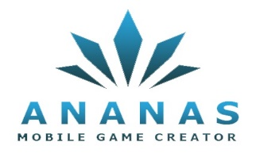
Ultimate Organization Website
(UOW)

Ultimate Website. |  | Project Name
An interactive website that works efficiently on all computers, smartphones and tablets using the latest programming and website design technologies. |  | Description
- Interactive website.  - Built-in Database content management service.  - Unlimited Organization-owned email (Ex: contact@organization.org)  - A profile of the organization in PDF format is available for direct download.  - A newsletter system will enable you to send emails to your subscribers periodically |  | Project Details
Cost (USD) |  | Agenda
100 | - Analysis
150 | - Dashboard design
340 | - Website design
70 | - Linking with social networks and preparing for search engines
125 | - Implementation, follow-up and supervision for a period of one Year after free period client pay 30% annually for maintaince cost
146 | - Training
931 | Total
5 weeks

